**Personal Information**

My name is Abdulmalik Nakoa, people just call me malik. My Rmit student number is S3973358 and my student email address is ([s3973358@student.rmit.edu.au](mailto:s3973358@student.rmit.edu.au))

I was born and raised in a country called Libya in its capital city Tripoli located in the middle top of Africa . I was raised a Muslim in a middle eastern culture environment where everyone is named muhammed and everyone warns you not to eat pork, our main language was Arabic until I moved to Australia in 2011 to where I am today writing this assignment. As you can imagine it was a big transition coming to an entirely different country and having to learn a completely new language, It was such a mix I would end up speaking a sentence in half arabic and half English and sometimes I still do it till this day. I have finished primary school and high school which sums up to 12 years of schooling/hell. growing up I loved playing video games which started on a original ps2 playing gta San Andreas and god of war, till getting introduced to a ps3 and playing one of the most popular games of all time call of duty black ops 2 and the last of us, from there its always been gaming, constantly wasting mass amounts of money on games consoles and finally my own hand built pc, I eventually got so good at games I could get decently good at any game in about a hour or so of gametime. I also enjoyed playing football/soccer growing up and played for Preston lions. my first and most favorite pet was my kitten Tora. She saw herself as an apex predator and when she looked at herself in the mirror, she saw a tiger. She would literally bring me prey such a bird to prove her worthiness.

**Interest in IT**

IT will always have a place in my life. My interest in IT first started as I gained maturity and age when I realized that IT is so deeply engraved in our life that we do not notice it often. My love for IT got ignited and launched into space once I first built my own personal computer. I bought all the parts myself, learned about all the components their speeds, what the hell a ryzen 5800x cpu 3.8 ghz clocked to 4.9ghz does and why RAM sticks ram information so quickly. This experience magically opened curiosity holes in my brain making me think, how do computers communicate and how do they know what to do? What languages do they speak? how? Why? What? Why does this link specifically take so long to load?

What makes my computer connect to the internet?

How does my graphics card display this gibberish on my screen?

After this spark, it led me to further research I learnt skills on HTML and CSS through YouTube and websites, which led to me to another whole different aspect of IT, the Cybersecurity Aspect. This made me fall even more in love with IT and programming and all the fun little things of IT. I taught myself how to use virtual machines and set up my own linux machine using virtual box, I played around with all the open-source tools that come with linux too such as nmap, aircrack.ng and the most fun of all John the ripper. Lets not talk about the illegal things that I DID NOT do but I also had a look onion sites and how to access them too. All this information and research and knowledge gained for IT led me to finding this show called Mr Robot, after watching the hacking and IT aspects of this show I wanted to study IT and hopefully learn more in depth about IT and how things work!

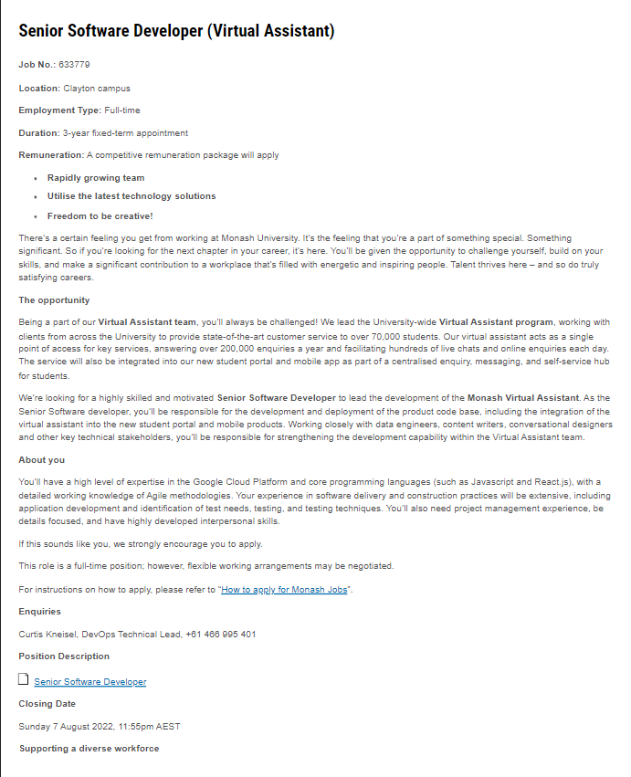I originally wanted to study at Latrobe University for a bachelor’s degree in Cybersecurity but I came to my senses and realized that IT had more broad information on IT and still has information to share on security and networking which is my main interest. I chose to study IT at Rmit due to their number 1 graduate employment statistic. Employment for Cybersecurity/IT graduates is hard according to my research due to employers wanting lots of experience and no employer wanting to train students.

**Ideal Job**

My ideal job is a software developer. It includes writing, developing and designing software or code that either does something on its own or wait for someone to come tell it what to do and sculpting it to a point where it is understandable and appealing to a human being. <https://careersmanager.pageuppeople.com/513/cw/en/job/633779/senior-software-developer-virtual-assistant?lApplicationSubSourceID=11305>

this position includes being a software developer who programs and designs a virtual assistant which is needed to be integrated into student portals and the university website. They require the software developer to be very experienced and have high expertise in google cloud and core programming languages such as java wants this virtual assistant to be the main access point for students to obtain all the key services they require, so this virtual assistant will need very detailed code. They also want the software developer to work with other stakeholders such as data engineers closely in order to build the best result possible which requires teamwork and communication skills. This job (software development) is appealing to me because its making something come to life digitally. A virtual assistant which will be used or accessed by over 70000 students is amazing. Making a program that successfully runs and responds to the users answers or inputs and does what it is told to do is so interesting to me, This job fits this perfectly.

This job application requires a software developer who is experienced in writing code and has expertise in not just 1 programming language but the core programming languages. They need someone who has major experience constructing software and has excellent project management skills. They also need teamwork and communication skills in order to build the absolute best software possible with shared knowledge.

My skills and qualifications include basic knowledge of python and entry level information on IT and web development. I currently am working on my programming language expertise and will gain more communication and teamwork skills for assignment 2 and 3 group projects during this semester which will be helpful for this job application as they need multiple people to work on one project.

In order for me to gain the appropriate knowledge and skills for this job I will need to complete my bachelor of IT and continue building my teamwork and communication skills during class by participating and taking more action in group activities to boost these skills. I don’t have the up to date qualifications for this job but after this degree and some work experience I should be able to achieve this goal. I plan to use my degree to gain the appropriate experience in software development and working alongside other software developer to gain teamwork and communication skills.

**Personal Profile**

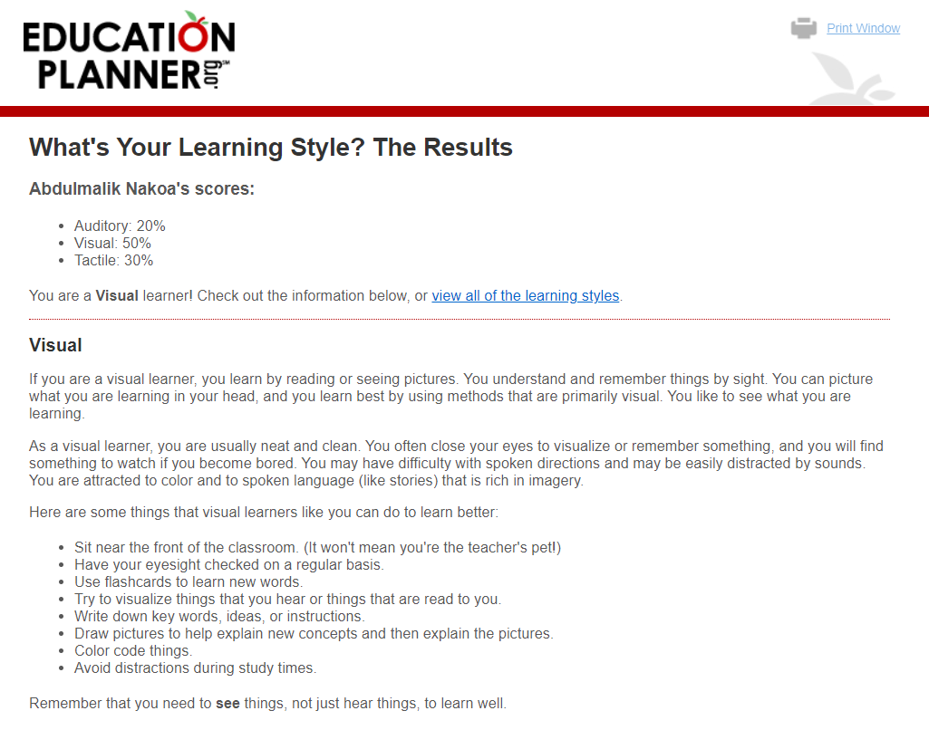

**Personality type**: [Defender (ISFJ-T)](https://aus01.safelinks.protection.outlook.com/?url=https%3A%2F%2Fwww.16personalities.com%2Fisfj-personality%3Futm_source%3Dwelcome-turbulent-defender%26utm_medium%3Demail%26utm_campaign%3Dresults%26utm_content%3Dtype-personality-0&data=05%7C01%7Cs3973358%40student.rmit.edu.au%7Cf765542be541420eb64108da761c211b%7Cd1323671cdbe4417b4d4bdb24b51316b%7C0%7C0%7C637952160449454915%7CUnknown%7CTWFpbGZsb3d8eyJWIjoiMC4wLjAwMDAiLCJQIjoiV2luMzIiLCJBTiI6Ik1haWwiLCJXVCI6Mn0%3D%7C3000%7C%7C%7C&sdata=cuGvkGm92DxlD2meO7cj%2FbcYwwNENNMu1u8BKaVl2Ss%3D&reserved=0)  
**Traits**: Introverted – 91%, Observant – 51%, Feeling – 52%, Judging – 65%, Turbulent – 78%  
**Role**: Sentinel  
**Strategy**: Constant Improvement

<https://bigfive-test.com/result/62ebcd729acbc6000968d2b2>

My test results conclude that I am a very self-conscious and introverted person. This test to me shows that I am rather shy or afraid to approach people. It tells me that I am more of a sole, independent worker instead of being in a team environment. I need to change this and improve myself in team environments in order to obtain the best results not only as a software developer but as an IT specialist in general.

these test results give a general direction of the person I am to help not only employers but for me to see what areas aim excelling at and what needs to be improved. All 3 tests taken lean on the fact that I am a little introverted which may be a difficult obstacle for me as I need to work in a group for my assignments. I may not participate or be to afraid to give feedback or ask questions.

If I do not participate in my groups and not put my opinions out there may put my team behind or lack information to help them. I should take these into account when working with my team by putting myself out there and doing the things im afraid to do, like getting to know people and joining in conversation in order to not let my team down and work to the best of my ability.